**PROJECT PROPOSAL**

GROUP MEMBERS :

* ABDUL BASIT (20K-0333)
* MUHAMMAD YASIR JAMAL (20K-0158)
* ANAS HASSAN (20K-1726)
* MUHAMMAD WARZAN (20K-1649)

PROJECT’S OBJECTIVE :

Our project’s objective is to design the most basic and fundamental part of the Central Processing Unit (C.P.U) that is capable of performing both arithmetic and logic operations i.e Arithmetic And Logic Unit (A.L.U)

COMPONENTS USED :

* **FOR ADDITION :**

4- bit full adder IC (74LS83)

5 white Leds

* **FOR SUBTRACTION :**

4 – bit full adder IC (74LS83)

Inverter IC (7404)

4 green Leds

* **FOR COMPARATOR :**

XNOR IC (74266)

4 AND ICS (7408)

OR IC (7432)

2 Inverter ICS (7404)

3 yellow Leds

* **OTHER MAIN COMPONENTS :**

3 Breadboards , 9 – volt power supply , jumper wires along with simple wires and some 220 -300 ohm resistors .

CIRCUIT DIAGRAM :

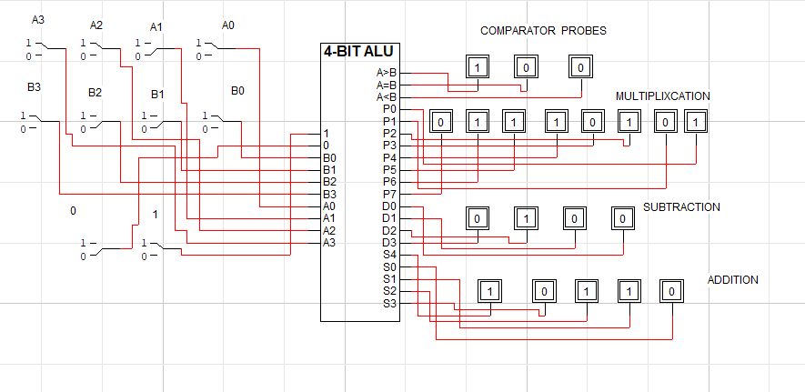

ABSTRACT / BRIEF DISCRIPTION OF PROJECT:

We are going to design 4 – bit A.L.U i.e can perform the basic arithmetic and logic operations such as addition ,subtraction , multiplication and comparasion between two 4- bit binary numbers on both hardware and software . We will give input to the system by 8-bit switches and the output will be shown on the leds .

**>>>>>>>>>>>>>>** **THANK YOU** **<<<<<<<<<<**